Integrating Mercury 2 with Agno Framework for an Autonomous Financial Analysis Agent

1. Executive Summary
This document presents the implementation of an autonomous AI agent using the Agno framework, where the OpenAI model approach was replaced with Mercury 2, a model provided by Inception Labs. The implementation was done as part of the task based on the article “Beyond Chatbots: A Practical Guide to Building Autonomous AI Agents with Agno”, where the original model usage was OpenAI-oriented, but the task specifically required replacing it with Mercury 2.
The key requirement was:
- use the same Agno agent architecture,
- replace the OpenAI model with Mercury 2,
- obtain the API key from Inception Labs,
- leverage the fact that Mercury 2 is OpenAI API compatible,
- and validate whether it works properly in a tool-enabled autonomous agent.

A working proof-of-concept was successfully built. The agent was designed as a financial analyst AI agent that uses:
- YFinanceTools → to fetch stock and financial data
- DuckDuckGoTools → to fetch recent web/news information
The agent was prompted to:
Analyze NVIDIA (NVDA) and tell me if it’s a good time to buy.
The output successfully demonstrated:
- tool invocation,
- financial data retrieval,
- recent news search,
- pros and cons analysis,
- risk analysis,
- structured recommendation,
- investor-profile-based suggestion.
Additionally, an important practical finding was observed during testing:
Mercury 2 did not reliably produce the expected output when the instruction behaviour aligned with a developer-role style pattern, but worked correctly after shifting the instructions to a system-role style behaviour.
This finding is significant because it shows that although Mercury 2 is OpenAI API compatible, message role handling and instruction hierarchy may behave differently in practice when used through frameworks such as Agno.
Final result:
The implementation proves that Mercury 2 is a practical drop-in replacement for OpenAI-compatible model integrations in Agno, especially for tool-driven autonomous agents.

2. Project Objective and Task Requirement
2.1 Objective
The primary objective of this implementation was to validate whether an Agno autonomous AI agent originally designed around an OpenAI-compatible chat model could be adapted to use Mercury 2 from Inception Labs with minimal code changes.
2.2 Task Requirement
The task given was essentially:
“Build the agent shown in the Agno article, but instead of using the OpenAI model, use Mercury 2. Get the API key from Inception Labs. Mercury 2 is OpenAI-compatible, so it should work like OpenAI.”
2.3 Expected Outcome
The expected outcome of the task was:
- replace the OpenAI backend model with Mercury 2,
- retain the Agno agent framework structure,
- keep tool integrations intact,
- verify if the agent can still perform autonomous tool-driven execution,
- and document the implementation and results.

3. Problem Statement
Modern AI agent frameworks like Agno are often designed around standard chat model abstractions. Many such abstractions are originally built with OpenAI-style APIs in mind. The challenge in real-world systems is whether alternative providers can be integrated without requiring:
- major code rewrites,
- custom adapters,
- tool orchestration changes,
- or prompt redesign.
The problem explored here was:
Can Mercury 2 (Inception Labs) be used as a practical replacement for an OpenAI model inside Agno for a real autonomous agent use case?
This includes testing:
- model compatibility,
- tool calling behaviour,
- output quality,
- prompt adherence,
- and practical integration constraints.

4. Reference Article Context
The implementation is inspired by the article:
“Beyond Chatbots: A Practical Guide to Building Autonomous AI Agents with Agno”
by Levi Doron (Medium article referenced in the task).
Why this article matters
The article focuses on moving from:
- simple chatbot-style interactions
to
- autonomous AI agents that can:
  - reason,
  - call tools,
  - retrieve information,
  - and complete tasks end-to-end.
This is directly aligned with what Agno is designed for.
Key relevance to this project
The article’s agent pattern was reused conceptually, but the implementation was modified to:
- replace the original OpenAI model path
- with Mercury 2
- while preserving the agent + tools architecture
Note: The exact Medium article page may vary in accessibility, but the task requirement clearly centred on reproducing the Agno autonomous agent pattern while replacing the model backend.

5. About Mercury 2 (Inception Labs)
5.1 What is Mercury 2?
Mercury 2 is a model offered by Inception Labs, positioned as a high-speed reasoning model designed for:
- chat completions,
- agentic workflows,
- tool use,
- structured outputs,
- long context processing,
- low-latency use cases.
Inception states that its platform is OpenAI-compatible, meaning existing OpenAI-style client integrations can be reused with a different endpoint and model ID.
5.2 Key Relevant Capabilities
According to Inception’s docs and model pages, Mercury supports:
- OpenAI-compatible API
- Chat completions endpoint
- Tool calling
- Structured outputs
- 128K context window
- OpenAI-style model invocation
5.3 Why This Matters
This makes Mercury 2 suitable for:
- Agno agents
- LangChain-based systems
- LiteLLM/OpenAI wrapper-based systems
- autonomous workflows
- tool-augmented assistants
- RAG pipelines
- multi-step reasoning agents

6. Why Mercury 2

6.1 OpenAI-Compatible Integration
Mercury 2 can be used through the same general chat-completion style used by OpenAI-compatible SDKs, which makes it ideal for frameworks that abstract the model layer.
6.2 Minimal Migration Effort
Instead of redesigning the agent, only these fields needed to change:
- model id
- API key
- base URL
This is extremely important in production systems because it reduces migration complexity.
6.3 Strong Fit for Agentic Workflows
Mercury’s documented support for:
- tool use
- structured output
- long context
- fast inference
makes it a natural fit for autonomous AI agents.
6.4 Strategic Value
Using Mercury 2 demonstrates:
- vendor flexibility
- lower lock-in
- compatibility validation
- faster experimentation across providers

7. Why Agno Framework Was Used
7.1 What Agno Provides
Agno is designed to build:
- autonomous agents,
- tool-using agents,
- workflow-capable AI systems,
- structured response pipelines.
7.2 Why It Is a Good Match
Agno makes it easy to combine:
- a chat model
- tools
- prompt instructions
- rendering behavior
in a single agent object.
7.3 Why This Was Important for the Task
The task was not to build a raw API demo.
It was to prove that Mercury 2 can work inside an actual agent framework.
That is why using Agno is more valuable than simply calling Mercury 2 directly.

8. Solution Overview
8.1 Implemented Agent Type
The implemented agent is a:
Financial Analysis Autonomous Agent
8.2 Agent Responsibilities
The agent was instructed to:
- act as a senior financial analyst
- fetch live financial data
- search recent news
- summarize pros and cons
- provide an investment recommendation
8.3 Tools Used
The following tools were integrated:
- YFinanceTools()
  - current stock price
  - financial metrics
  - revenue / EPS / market data (depending on query/tool path)
- DuckDuckGoTools()
  - recent news
  - general web search
  - recent financial context
8.4 Test Use Case
The agent was asked:
“Analyze NVIDIA (NVDA) and tell me if it’s a good time to buy.”

9. Final Implemented Code
9.1 Actual Code Used in the Project
import os
from dotenv import load_dotenv
from agno.agent import Agent
from agno.models.openai import OpenAIChat
from agno.tools.yfinance import YFinanceTools
from agno.tools.duckduckgo import DuckDuckGoTools
# Load environment variables
load_dotenv()
# Initialize the Agent
agent = Agent(
model=OpenAIChat(
id="mercury-2",
api_key=os.getenv("INCEPTION_API_KEY"),
base_url="https://api.inceptionlabs.ai/v1",
),
tools=[
YFinanceTools(),
DuckDuckGoTools()
],
markdown=True,
)
# Fire it up
agent.print_response("""
You are a senior financial analyst.
Use yfinance to get financial data.
Use DuckDuckGo to search for recent news.
Always provide a summary of the pros and cons of an investment.
Analyze NVIDIA (NVDA) and tell me if it's a good time to buy.
""")

10. Code Explanation
10.1 Import Statements
import os
from dotenv import load_dotenv
from agno.agent import Agent
from agno.models.openai import OpenAIChat
from agno.tools.yfinance import YFinanceTools
from agno.tools.duckduckgo import DuckDuckGoTools
Explanation:
- os → used to access environment variables
- load_dotenv → loads the API key from .env
- Agent → Agno’s main autonomous agent abstraction
- OpenAIChat → Agno’s OpenAI-compatible model wrapper
- YFinanceTools → stock/financial data retrieval
- DuckDuckGoTools → web/news search retrieval

10.2 Load Environment Variables
load_dotenv()
This reads the .env file and loads:
INCEPTION_API_KEY=your_actual_api_key_here
Why this is important:
- secure API key management
- avoids hardcoding secrets
- production-ready practice

10.3 Model Configuration
model=OpenAIChat(
id="mercury-2",
api_key=os.getenv("INCEPTION_API_KEY"),
base_url="https://api.inceptionlabs.ai/v1",
)
This is the core change required by the task.
What changed compared to a normal OpenAI setup:
- id="mercury-2"
- api_key=INCEPTION_API_KEY
- base_url="https://api.inceptionlabs.ai/v1"
Why this is important:
This proves Mercury 2 can be used as a drop-in OpenAI-compatible backend inside Agno.
Inception explicitly documents OpenAI-compatible usage and OpenAI-style endpoint access.

10.4 Tool Configuration
tools=[
YFinanceTools(),
DuckDuckGoTools()
]
Why these tools were selected:
This creates a realistic financial analysis agent by combining:
- structured market data (YFinance)
- fresh contextual information (DuckDuckGo)
Why this matters:
Without tools, the model would rely mainly on internal knowledge.
With tools, the agent becomes:
- more current,
- more factual,
- more agentic,
- more aligned with real-world autonomous AI usage.

10.5 Markdown Rendering
markdown=True
This makes the response display in a clean formatted structure, improving readability of:
- headings
- tables
- bullets
- sections
This is especially useful for:
- financial analysis
- report-style outputs
- documentation screenshots

10.6 Prompt Design
You are a senior financial analyst.
Use yfinance to get financial data.
Use DuckDuckGo to search for recent news.
Always provide a summary of the pros and cons of an investment.
Analyze NVIDIA (NVDA) and tell me if it's a good time to buy.
Why the prompt is strong:
It clearly defines:
- role
- tools
- expected output format
- task target
This is a good agent prompt because it instructs the model on:
- identity,
- tool usage,
- reasoning expectations,
- final decision format.

11. Agent Workflow / Execution Flow
11.1 Logical Flow
User Prompt
↓
Agno Agent
↓
Mercury 2 (OpenAI-compatible model through Inception API)
↓
Task interpretation and tool planning
├── YFinanceTools → financial data retrieval
└── DuckDuckGoTools → recent web/news search
↓
Mercury 2 synthesizes results
↓
Pros / Cons / Risks / Recommendation
↓
Final financial analysis report
11.2 Practical Execution Observed
The agent performed tool calls such as:
- get_current_stock_price(symbol=NVDA)
- web_search(query=NVIDIA financials 2023 revenue profit margin EPS, max_results=5)
- web_search(query=NVIDIA fiscal 2024 earnings results, max_results=5)
- search_news(query=NVIDIA news March 2026, max_results=5)
What this proves:
The agent did not simply generate an answer from model memory.
It:
- decomposed the task,
- selected tools,
- gathered external data,
- and synthesized a final response.
That is the hallmark of an autonomous AI agent.

12. Prompt Design and Behaviour
12.1 Prompt Strategy
The prompt was intentionally designed to enforce:
- a professional analyst role
- explicit tool usage
- structured pros/cons output
- a concrete decision request
12.2 Why This Worked Well
This style of prompt is effective because:
- it reduces ambiguity
- it pushes the model to invoke tools
- it frames the output as an analysis report
- it encourages multi-step reasoning
12.3 Practical Note
In agent systems, prompts should define:
- Role
- Tools to use
- Expected output sections
- Task scope
- Decision format
Our prompt successfully did that.

13. Important Implementation Finding: Developer Role vs System Role

13.1 Observed Issue
During testing, a key practical issue was encountered:
Mercury 2 did not reliably produce the expected output when the instruction behaviour aligned with a developer-role style prompting pattern.
However:
After changing the instruction behaviour to a system-role style prompt, the expected output was produced successfully.
13.2 What Happened
Initially:
- the agent setup / message structure behaved in a developer-style instruction pattern
- Mercury 2 did not consistently return the expected final output
After adjustment:
- the instructions were shifted to system-level behaviour
- Mercury 2 followed the instructions more reliably
- the tool-driven response was generated correctly
13.3 Practical Conclusion
For Agno + Mercury 2, the most reliable pattern observed was:
Use system-role style instructions for agent identity, tool directives, and output constraints.

14. Environment Setup and Prerequisites
14.1 Required Packages
Install the following:
pip install agno python-dotenv yfinance duckduckgo-search
Depending on Agno version, some tools may already be included or installed via the Agno package itself.
14.2 .env File
Create a .env file in the project root:
INCEPTION_API_KEY=your_inception_api_key_here
14.3 Python Version
Recommended:
- Python 3.10+
- virtual environment recommended
14.4 Run Command
python app.py

15. Output Screenshots and Result Analysis
Below is the screenshots of the output.

Output:
Screenshot 1: Agent Execution and Tool Calls

Description: Terminal execution showing:
- python app.py
- prompt message
- Mercury 2 model invocation
- tool calls for YFinance and DuckDuckGo
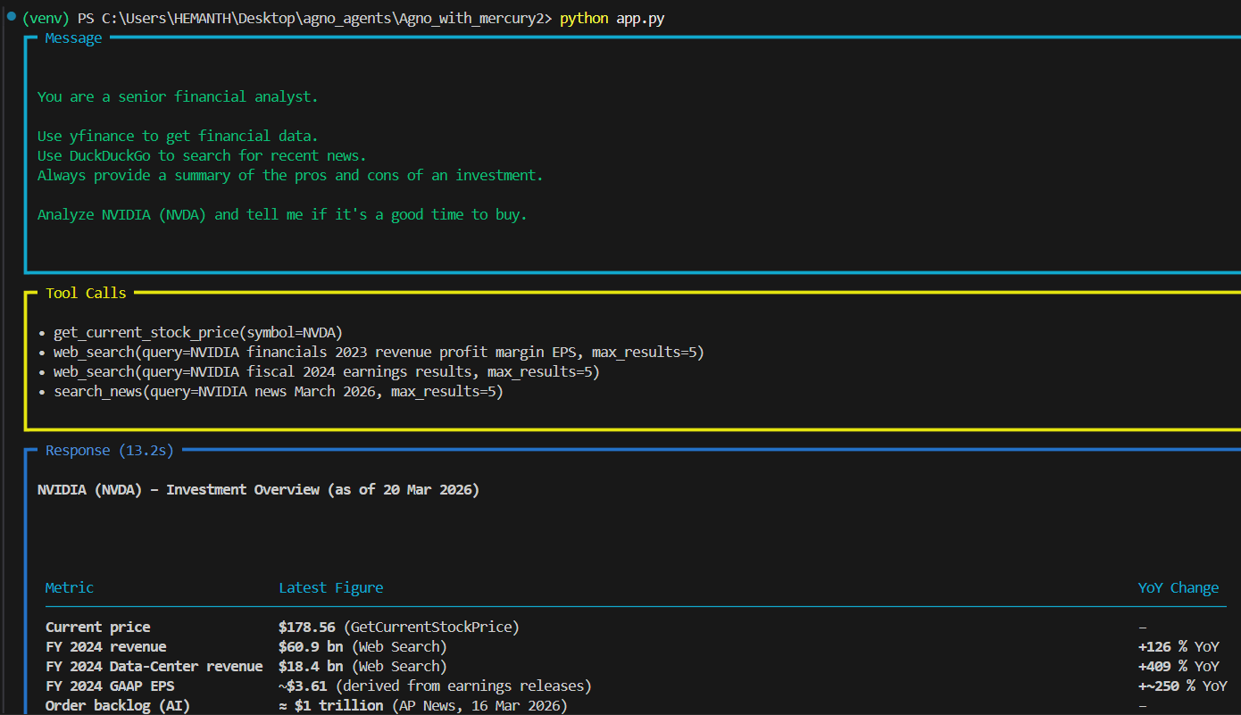

Screenshot 2: Final Output (Investment Overview + Metrics)
Description: Final response showing:
- NVIDIA investment overview
- current price
- revenue and EPS
- recent news
- structured financial context
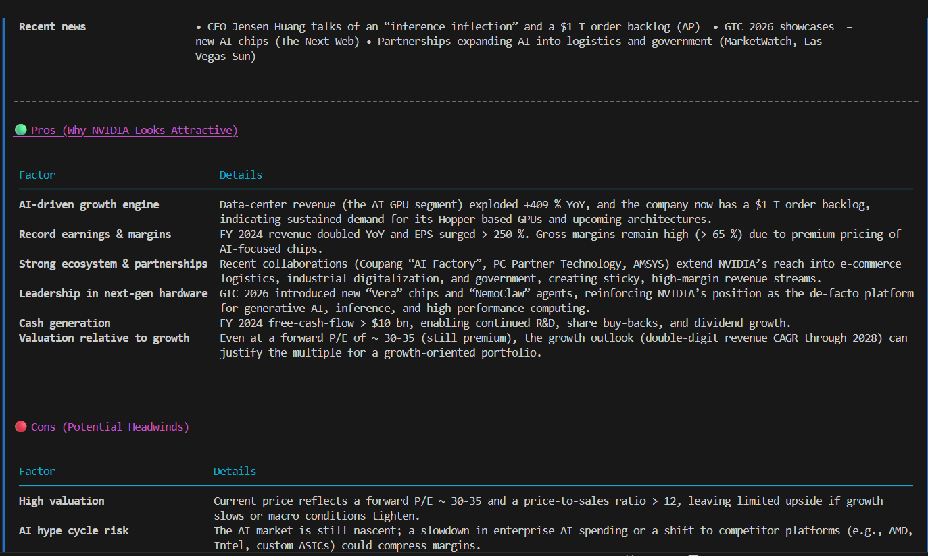

Screenshot 3: Final Output (Pros / Cons / Risks / Recommendation)
Description: Final response showing:
- pros section
- cons section
- risks
- recommendation (“Buy with Caution” / “Moderately Positive” style)
- investor scenario suggestions
- watch points for the next 3–6 months
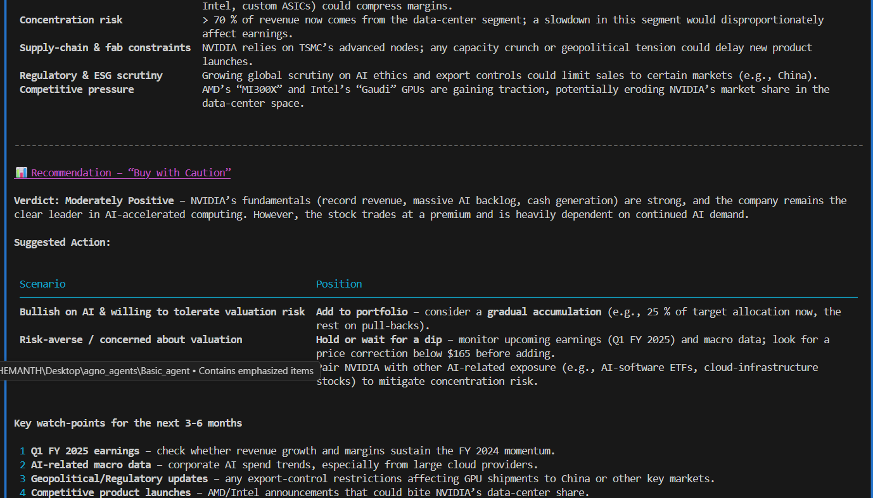

16. Benefits of This Implementation
16.1 Drop-In OpenAI-Compatible Replacement
Only three main changes were needed:
- model id
- API key
- base URL
This is highly efficient from an engineering perspective.
16.2 No Framework Rewrite Needed
Agno’s OpenAIChat wrapper was reused directly.
That means:
- no custom provider adapter
- no re-architecture
- no tool layer rewrite
16.3 Tool-Augmented Agent Behavior Preserved
Mercury 2 was able to:
- understand tool usage requirements
- trigger tools
- use results in reasoning
16.4 Strong for Real Use Cases
This exact pattern can be reused for:
- financial research agents
- procurement agents
- market intelligence agents
- news monitoring agents
- stock watch assistants
- risk analysis agents
16.5 Vendor Flexibility
This demonstrates a strategic architecture benefit:
Build once with OpenAI-compatible abstractions, then switch providers as needed.

17. Limitations / Risks / Notes
17.1 Tool Output Quality Matters
The final response quality depends on:
- YFinance data freshness
- DuckDuckGo search quality
- availability of public sources
- relevance of search results
17.2 Financial Advice Caution
This system is a research assistant, not a licensed financial advisor.
For production:
- add disclaimers
- include human review
- avoid direct investment guarantees
17.3 Role Behaviour Differences
The developer-role vs system-role issue is important.
Even if a model is OpenAI-compatible:
- role behaviour may differ
- instruction hierarchy may differ
- framework defaults may affect output
17.4 Version Differences
Depending on Agno version or Inception platform updates:
- model names may vary (mercury, mercury-2)
- parameters may evolve
- tool calling behavior may improve over time
17.5 Pricing and Platform Info Should Be Verified
Inception’s docs show current platform details such as:
- OpenAI-compatible API
- 128K context
- tool calling
- structured outputs
- pricing examples (e.g., Mercury listed at $0.25 input / $1.00 output per 1M tokens on current docs)
These should always be verified at the time of deployment.

18. Recommended Best Practices
18.1 Prefer System-Level Instructions
For Agno + Mercury 2:
- place agent identity in system-style instructions
- place tool usage rules in system-style instructions
- place output format expectations in system-style instructions
18.2 Keep Prompts Explicit
Always define:
- role
- tools
- expected sections
- decision style
18.3 Add Output Structure Requirements
For even better consistency, specify:
- investment overview
- key metrics
- recent news
- pros
- cons
- risks
- final recommendation
18.4 Use Tool Configuration More Explicitly
A stronger version of YFinance can be configured to expose:
- stock price
- analyst recommendations
- company info
- company news
18.5 Keep Secrets in .env
Never hardcode:
- API keys
- endpoints
- secrets

19. Final Conclusion
This implementation successfully demonstrates that Mercury 2 can be integrated into the Agno framework as a practical replacement for an OpenAI-style model backend.
The task objective was fully achieved:
- The original OpenAI-style agent architecture was preserved
- Mercury 2 was integrated through Agno’s OpenAIChat wrapper
- The agent successfully used:
  - YFinanceTools
  - DuckDuckGoTools
- The agent completed a real task:
  - Analyze NVIDIA (NVDA) and determine whether it is a good time to buy
- The output was:
  - structured
  - tool-driven
  - report-style
  - high quality
  - practically useful
Most important technical finding
A significant implementation insight was observed:
While Mercury 2 is OpenAI-compatible, instruction-role behaviour is not always identical across providers. In this Agno integration, system-role prompting proved more reliable than developer-role prompting, and this change was necessary to obtain the expected output consistently.

